Java Multithreading concept is implemented by using the following two models.
- Green thread model
- Native OS model
Green Thread Model:
- The thread which is completely managed by JVM without taking underlying OS support is called green thread.
- Very few OS like sun solaris provide support for green thread model.
- Anyway green thread model is deprecated and is not recommended to use.
Native OS Model:
- The thread which is managed by JVM with the help of underlying OS is called native os model.
- All windows based os provide support for native os model.
How to stop a thread:
- We can stop a thread in the middle of execution by calling the stop() present in thread.
- If call stop() on a thread, then the thread immediately entered into dead state.
- Stop() is deprecated.
- It is not recommended to use.

Mehtod: public void stop()

Example:
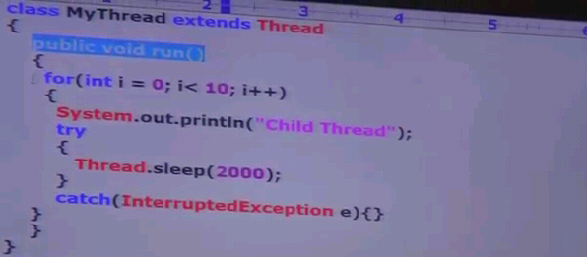
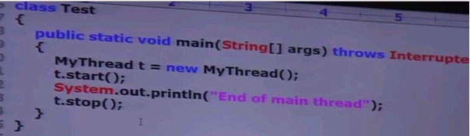


How to suspend & resume of a thread:
- We can suspend a thread by using suspend() of a thread class. Then immediately, the thread will be entered into suspended state
- We can resume a suspended thread by using resume() of thread class. Then immediately the suspended thread can continue its execution.
- Both methods are deprecated and not recommended to use.

Methods:
Public void suspend()
Public void resume()

Life cycles:


